Integral Green Slovenia:
A Social, Knowledge- & Value-Based Economy and Society at the Heart of Europe
by Darja Piciga, Alexander Schieffer & Ronnie Lessem (Editors)
and over 40 Slovenian Contributors

Integral Green Slovenia is the second book in the Integral Green Society and Economy series. It tells the unique story of a society pursuing a newly holistic and green approach to economics.

The story of Integral Green Slovenia takes us to Slovenia: a country located at the historic crossroads of European civilisation; a country dedicated to the European Union which it only joined in 2004; a country with a unique human and natural potential, but which faces enormous economic and political difficulties; a country searching for a new, sustainable economic model that is authentic to its own social and cultural context, that can serve to address its difficulties and release its full potential, and that can, simultaneously, make a contribution to the sustainable development of the European Union.

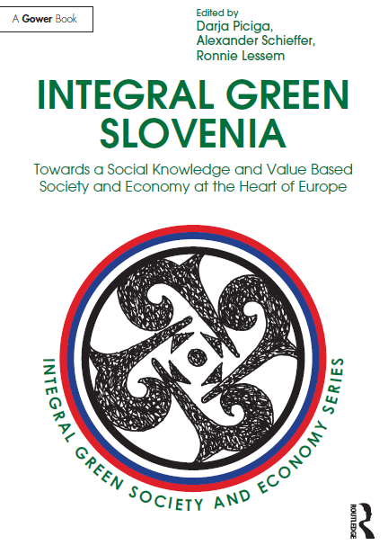 | Integral Green Slovenia is framed by real-life stories of integral communities and organisations on a path of social innovation for sustainability. Municipalities Solčavsko, Šentrupert and Poljčane, regional development model of the Heart of Slovenia, Biotechnical Centre Naklo, Kindergarten Slovenska Bistrica, high-tech companies Domel and Pipistrel, Institute Metron, green social enterprise Tekstilnica, Ekoci, InTerCeR, Cooperative Dobrina and Urban Furrows as cases of grassroots developments, Slovenian Forum of Social Entrepreneurship, young creators succeeding with coworking and crowd-funding, and other distinguished practice cases draw on the Slovenian history and on each other. Among the successful models from the past, sustainable forestry, common land management and classical cooperatives are highlighted. From searching for Slovenian identity to study circles and co-creating a network society; from geomancy and geoculture to biodynamic school gardens; from addressing climate change to education for sustainable development – all this is Integral Green Slovenia.

Furthermore, Slovenian integral green cases show that “smart integration” of EU policies is already happening in practice: nationally and internationally recognised successes of these cases are also the result of smart use (integration) of EU programmes and measures for green economy (including organic food self-sufficiency and energy self-sufficiency, sustainable local development, green tourism), social economy (with cooperatives, social enterprises and economic democracy), social responsibility, strategic environmental assessment … As a whole, this book serves as a global showcase for an integral European economy, dealing with an entire society at the geographic heart of Europe.

As you read through Integral Green Slovenia, you are not confronted with a discordant set of chapters, but invited into an interdependent storyline. Inspired by the nature and culture as well as historical evolution of Slovenia, all contributors see each other as a continuation of this foundational story.

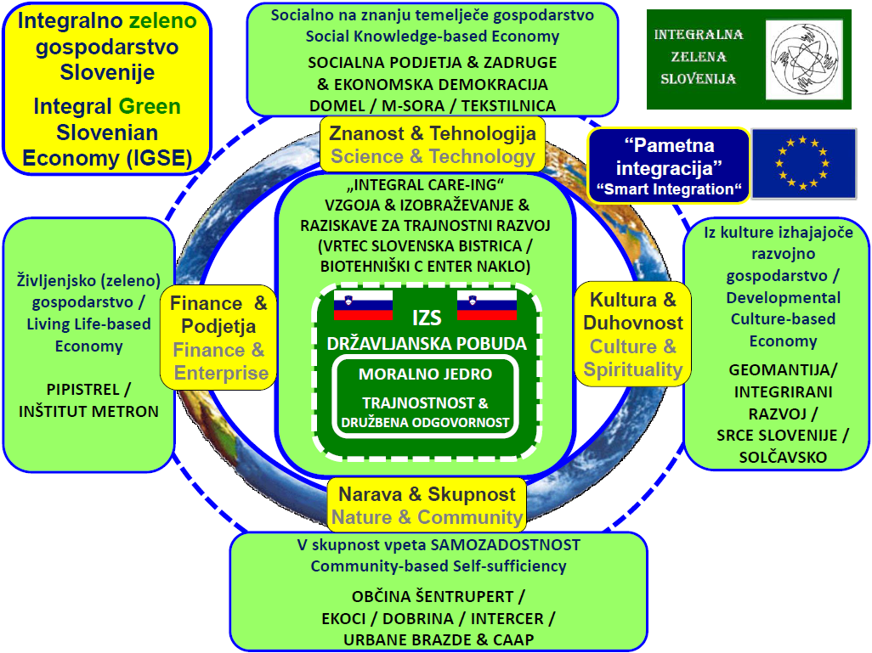

Integral Green Slovenia – Lead Model

The Integral Green Slovenia is dedicated to Slovenia, to Europe and to the World, in the spirit of the Slovenian anthem, with the words of the poet France Prešeren:

“Long live all the nations,
Who long to see No more shall foes,
That all men free but neighbours be.”

CONTRIBUTORS TO INTEGRAL GREEN SLOVENIA: Martina Bavec; Štefan Bertoncelj; Klemen Bizjak; Nevenka Bogataj; Ivo Boscarol; Iztok Erjavec; Milojka Fekonja; Andrej Firm; Rupert Gole; Martina Gopurn; Aleksandra Gradišek; Maja Kolar; Vesna Kolar Planinšič; Jože Kos; Tanja Kramar; Andrej Kranjc; Karin Lavin; Robi Lavin; Ivana Leskovar; Ronnie Lessem; Milena Maček Jerala; Barica Marentič Požarnik; Matjaž Mulej; Jožef Osterc; Gorazd Pavlek; Andrej Pečjak; Mojca Pešak; Darja Piciga; Sebastjan Pikl; Marijan Pogačnik; Marko Pogačnik; Jožica Rejec; Janez Rihtaršič; Irena Rotar; Ana Savšek; Alexander Schieffer; Marko Slapnik; Tadej Slapnik; Stanka Stegne; Jernej Stritih; Barbara Šubic; Liliana Vižintin; Ana Vovk Korže; Urša Zgojznik; Edita Žugelj

THE EDITORS OF INTEGRAL GREEN SLOVENIA
Dr. Darja Piciga (darja.piciga@gmail.com)
is co-founder and leading figure of the Citizens’ Initiative for an Integral Green Slovenia. She embodies Trans4m’s integral approach in her professional and government career (fusing knowledge and experiences over a wide span of scientific, educational and policy areas) as well as in civil society activities (uniting stakeholders from all “integral worlds”).

Prof. Alexander Schieffer (schieffer@trans-4-m.com)
graduated from and lectures at St. Gallen University and is Co-Founder of the local-global Trans4m movement, headquartered in Geneva. With Ronnie Lessem, he developed the Integral Worlds approach, co-authored Integral Economics, as well as being a Joint Series Editor of the Transformation and Innovation Series and the Integral Green Society and Economy Series.

Professor Ronnie Lessem (lessem@trans-4-m.com)
is also Co-Founder of Trans4m. A graduate from Harvard Business School and London School of Economics, he is Zimbabwean by birth, and now a UK Citizen. He has been a management educator and consultant in Africa, Asia, Europe and America and is the author of over 30 books on the development of self, business and society.

THE MOVEMENT BEHIND INTEGRAL GREEN SLOVENIA

Citizens’ Initiative for an Integral Green Slovenia (http://integralna-zelena-slovenija.si/)
The Citizens’ Initiative for an Integral Green Slovenia, founded in April 2013 by a group of distinguished Slovenian experts and led by Dr. Darja Piciga, started to operate with a public address to the Citizens of Slovenia, calling for a sustainable approach to economics, building on the natural and cultural wealth of Slovenia. Since then, the initiative managed to grow, through dedication and determination, into a highly diverse group of individuals, institutions, initiatives, development centres and enterprises across all societal sectors – with each one of them contributing a vital piece to the Integral Green Slovenian mosaic. Their endeavours are based on the conviction that an integral green economic approach provides Slovenia with a realistic possibility to become within a decade a respected eco-country, a mutually cohesive and inclusive society with a thriving economy as well as a role model for high quality of living, in tune with the natural environment. Furthermore, the Citizens’ Initiative believes that Slovenia also has the opportunity to become the first country to systematically implement an integral, wholesome, and collaborative economy – for the benefit of Slovenia, Europe and the World.

INTEGRAL GREEN SOCIETY AND ECONOMY BOOK SERIES

This groundbreaking series introduces specific societies on their way to becoming “integral” and “green”. While there is a profusion of commendable books with “green” and “integral” credentials, they tend to be lacking in one or other of three major respects.

Firstly, they often focus on the ecological and technological aspects of “green” and are, hence, are not fully “integral”. By integral, series editors Ronnie Lessem and Alexander Schieffer incorporate not only nature and community, but also culture and spirituality, science and technology, politics and economics – altogether forming an integral, systemic whole.

Secondly, most integral books tend to be culture-free. They assume that the ideas advanced could apply anywhere in the world, whereas Lessem and Schieffer’s Integral Worlds approach takes account of the particularity of each society.

Thirdly, the increasingly popular notion of “integral” is generally associated with the approach of American philosopher Ken Wilber. While the editors acknowledge Wilber’s outstanding work, their own integral orientation goes beyond it, drawing on integral interpretations and applications of the entire world.

Building on these three premises, each volume of this series aspires to tease out the unique path of a country towards an “Integral Green Society and Economy”.

ENDORSEMENTS FOR INTEGRAL GREEN SLOVENIA

“This is a fascinating book about an extraordinary journey towards an Integral Green Slovenia, a vision of a sustainable society and economy. It argues that values and a moral economic core are the foundations of long-term sustainable economy and business, comprising all actors and all sectors.

Dr. Hoesung Lee, Chair of the Intergovernmental Panel on Climate Change (IPCC), co-recipient of the Nobel Peace Prize in 2007

“Integral Green Slovenia shows convincingly that deep values and a clearly articulated moral economic core are prerequisites for equity, equality and a sustainable economy. It thereby is in perfect harmony not only with Pope Francis’ recent encyclical Laudato Si, but also with the principles of the work that my friends and I are carrying out in Madagascar.”

Pedro Pablo Opeka, known as “Father Opeka”, Founder of Akamasoa in Madagascar, awarded with Legion of Honour

“As Europe is looking to create a new identity for itself, the dissolving of the old systems and silos is becoming more obvious every day. The trio's methodology, through invitation to explanation and then elaboration and participation is exemplary in its truly democratic approach, and in this approach is real resilience.”

Lawrence Bloom, Secretary General, Be Earth Foundation, UK; Former Chairman of UNEP’s Green Economy Initiative

“Because Circular economy and sustainability are at the top of the political agenda of the European Commission, we very much welcome the book Integral Green Slovenia and have no doubt that it is very useful reading for scholars and policy makers.”

Dr. Zoran Stančič, Head of European Commission Representation in Slovenia

“There is no other way for humanity on earth to prosper than to follow an integrated approach to sustainable development. But there are a few pioneers who are treating the impossible as though it is possible. Integral Green Slovenia represents such an integrated approach towards sustainable development on a societal level driven by a courageous citizens’ initiative.”

Dr. Ibrahim Abouleish, Chairman of SEKEM Group, Egypt; Winner Right Livelihood Award

PURCHASE the book: “Integral Green Slovenia – Routledge”:
https://www.routledge.com/Integral-Green-Slovenia-Towards-a-Social-Knowledge-and-Value-Based-Society/Piciga-Schieffer-Lessem/p/book/9781472469489

MORE INFORMATION: “Trans4m - Integral Green Slovenia”:

http://www.trans-4-m.com/integral-green-book-series/integral-green-slovenia-2/

CONTACT:
DR. DARJA PICIGA INTEGRAL GREEN SLOVENIA, A citizens' initiative for a wholesome life
darja.piciga@gmail.com in the internationally respected community of Slovenia
www.dpiciga.com http://integralna-zelena-slovenija.si/
+386 41 399 715 integralnaslovenija@gmail.com

